Mini Project Report

Name and PRN no: Ritesh Buchade [ RBT25CB049 ]

Name and PRN no: Girish Chinchpure [ RBT25CB050 ]

1. Title of the Project
Green Campus Waste Management System
A Java-based application to report, categorize, assign and track waste collection across different campus locations.

2. Problem Statement
Educational campuses generate waste every day in places such as the canteen, hostels, library, garden and sports ground. This waste is a mixture of recyclable material (paper, plastic, metal), non-recyclable material and organic waste (food scraps, leaves). In most campuses, waste problems are informed verbally or on paper, there is no proper record of what was reported, and there is no clear way to know whether a worker has been assigned or the waste has actually been collected.
Because of this, waste is not separated at source, collection is delayed, and the administration cannot monitor the work of the cleaning staff. There is a need for a simple system where users can report waste with its category, the administrator can assign collection tasks to workers, and everyone can track the status of every request.

3. Objective
The objectives of this mini project are:
- Allow users to report waste from different campus locations.
- Categorize every report as Recyclable, Non-Recyclable or Organic and show the correct disposal tip.
- Allow the administrator to assign collection tasks to workers.
- Track each request through the stages PENDING, ASSIGNED and COLLECTED.
- Show the total quantity of waste collected category-wise.
- Store the records permanently in a file so that data is not lost when the application is closed.
- Apply the Java concepts of Inheritance, Abstraction, Interfaces, Polymorphism, Collections, File Handling and the Applet life cycle in a single working project.

4. Methodology
The project was developed in a step-by-step manner using an object-oriented approach.
- Requirement analysis: The requirements were identified: users report waste, the administrator assigns it to workers, and the status is tracked until collection.
- Class design: Waste was modelled as an abstract class with three child classes. A common interface was created for actions that can be performed on a request, and a separate manager class was created for the business logic.
- Data handling design: ArrayList and HashMap were used to hold the data in memory, and a text file was used to store it permanently.
- User interface: A simple AWT-based screen was built using the Applet life cycle methods init(), start(), stop() and destroy().
- Testing: Each operation was tested with valid and invalid inputs, such as an empty description or collecting a request that is not yet assigned.

Status flow of a request:
Report Waste → PENDING → Admin assigns worker → ASSIGNED → Worker collects → COLLECTED
Java concepts used and their purpose
Concept | Where it is used | Purpose
Abstraction | Abstract class Waste | Defines common data and abstract methods getCategory() and getDisposalTip() without fixing their behaviour.
Inheritance | RecyclableWaste, NonRecyclableWaste, OrganicWaste extend Waste | Reuses the common fields and methods of Waste.
Interface | Interface Collectable implemented by Waste | Specifies the actions assignTo(), markCollected() and getStatus().
Polymorphism | Waste references holding child objects | The same call gives a different category and tip for each waste type.
Collections | ArrayList and HashMap in WasteManager | Stores all requests and workers and calculates category-wise totals.
File Handling | FileWriter, PrintWriter, BufferedReader | Saves and loads records from waste_data.txt.
Applet life cycle | GreenCampusApplet | init() builds the screen, start() loads data, stop() and destroy() save data.

5. Dataset, Tools & Technologies Used
Dataset
This project does not use any external dataset. The data is generated by the users while reporting waste and is stored in a plain text file named waste_data.txt. Each request is saved as one line with the fields separated by the “|” symbol:
Category|ID|Location|Description|Quantity|Status|Worker
Example: Recyclable|1001|Canteen|Plastic bottles|2.5|COLLECTED|Ramesh
Tools and Technologies
Tool / Technology | Use in the project
Java (JDK 17 / 21) | Programming language used to develop the application.
Eclipse IDE | Writing, compiling and running the code.
java.applet.Applet and AWT | Graphical user interface and life cycle methods (Frame, Panel, Choice, TextField, TextArea, Button, Label).
java.util (ArrayList, HashMap) | In-memory storage of requests, workers and summary.
java.io (FileWriter, BufferedReader) | Permanent storage of records in a text file.

6. Implementation
The application consists of seven Java files. The classes and their roles are given below.
Class / Interface | Type | Description
Collectable | Interface | Declares assignTo(), markCollected() and getStatus().
Waste | Abstract class | Holds ID, location, description, quantity, status and assigned worker. Declares abstract getCategory() and getDisposalTip().
RecyclableWaste | Child class | Category “Recyclable”; tip: send to the recycling unit.
NonRecyclableWaste | Child class | Category “Non-Recyclable”; tip: dispose at the designated landfill point.
OrganicWaste | Child class | Category “Organic”; tip: send to the compost pit / biogas plant.
WasteManager | Logic class | Reports, finds, assigns and collects requests, calculates the summary and handles file save/load.
GreenCampusApplet | Applet (GUI) | Screen for the user and administrator; contains the life cycle methods and main().

(a) Abstraction, Inheritance and Interface
Waste is an abstract class that implements the Collectable interface. The three waste types extend it and provide their own category and disposal tip.
public abstract class Waste implements Collectable {
protected int id;
protected String location, description;
protected String status = "PENDING";
public abstract String getCategory();
public abstract String getDisposalTip();
public void assignTo(String worker) {
this.worker = worker; this.status = "ASSIGNED";
}
public void markCollected() { this.status = "COLLECTED"; }
}

public class OrganicWaste extends Waste {
public String getCategory() { return "Organic"; }
public String getDisposalTip() {
return "Send to the compost pit / biogas plant.";
}
}
(b) Polymorphism
The manager stores all objects in one ArrayList<Waste>. When the list is displayed, the same toString() call prints the correct category for each object, depending on its actual child class. Similarly, the disposal tip shown after reporting depends on the type of the object created.
(c) Collections
An ArrayList<Waste> keeps all requests, an ArrayList<String> keeps the worker names, and a HashMap<String, Double> is used to calculate the total kilograms of waste for every category in the Summary option.
(d) File Handling
After every operation, the list is written to waste_data.txt. When the application starts, the file is read line by line and the objects are recreated, so records are not lost.
try (PrintWriter pw = new PrintWriter(new FileWriter(FILE))) {
for (Waste w : wasteList)
pw.println(w.toFileString());
} catch (IOException e) {
System.out.println("Could not save: " + e.getMessage());
}
(e) Applet life cycle
Method | Use in this project
init() | Called once; builds the user interface (report panel, display area and admin panel).
start() | Called when the applet becomes active; loads saved records from the file and refreshes the display.
stop() | Called when the applet becomes inactive; saves the records to the file.
destroy() | Called at the end; saves the records for the last time and releases resources.

Since modern JDK versions do not provide the appletviewer tool, a main() method was added which places the applet inside a Frame and calls init() and start(), and calls stop() and destroy() when the window is closed.
(f) Working of the application
- Report Waste: The user selects a location and category, enters a description and the quantity in kg, and clicks Report. A new request with a unique ID and status PENDING is created.
- Assign Task: The administrator enters the request ID, selects a worker and clicks Assign Task. The status changes to ASSIGNED.
- Mark Collected: After the worker finishes, the administrator enters the ID and clicks Mark Collected. The status changes to COLLECTED.
- Summary: Shows the total quantity of waste for each category.
Validation is included: an empty description, a non-numeric quantity or ID, an unknown ID, assigning a request that is already assigned, and collecting a request that is not yet assigned all produce a message instead of an error.

7. Results
The application was executed in Eclipse IDE and the user and administrator operations were carried out as shown below. The data entered during testing is given in the following table.
ID | Category | Location | Description | Qty (kg) | Status | Worker
1001 | Non-Recyclable | Library | Plastic Files | 10.0 | COLLECTED | Ramesh
1002 | Recyclable | Hostel | Electronics | 2.0 | COLLECTED | Anita
1003 | Organic | Library | Leftover veggies | 2.0 | COLLECTED | Suresh

Total waste by category: Non-Recyclable = 10.0 kg, Recyclable = 2.0 kg, Organic = 2.0 kg.
Test cases
No. | Test case | Expected result | Related operation
1 | Report valid waste | New ID created, status PENDING, disposal tip shown | Report
2 | Empty description | Message: “Please enter a description.” | Validation
3 | Non-numeric quantity or ID | Message asking for valid numbers | Validation
4 | Assign a PENDING request | Status changes to ASSIGNED with worker name | Assign Task
5 | Assign an already assigned request | Message that the request is already ASSIGNED | Assign Task
6 | Collect a request that is not assigned | Message that it must be ASSIGNED first | Mark Collected
7 | Collect an ASSIGNED request | Status changes to COLLECTED | Mark Collected
8 | Enter an ID that does not exist | Message “No request with ID …” | Validation
9 | Close and reopen the application | All earlier requests are loaded again from the file | File handling

Output screenshots
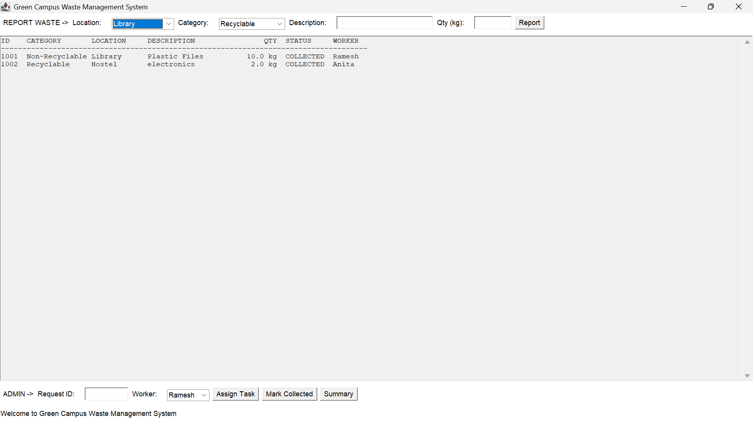
Figure 1: Main window of the application with saved requests loaded from the file
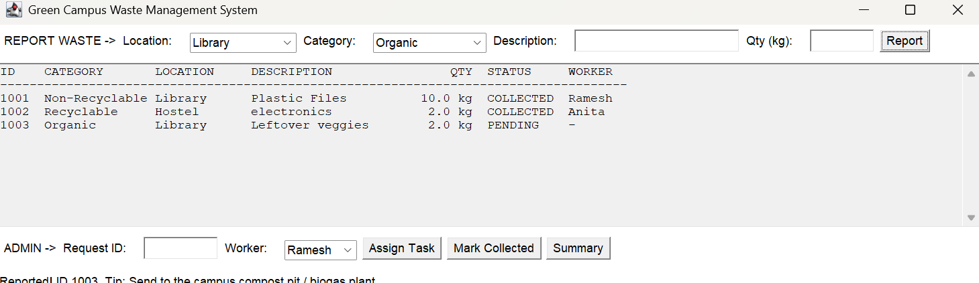
Figure 2: New waste reported (ID 1003) with status PENDING
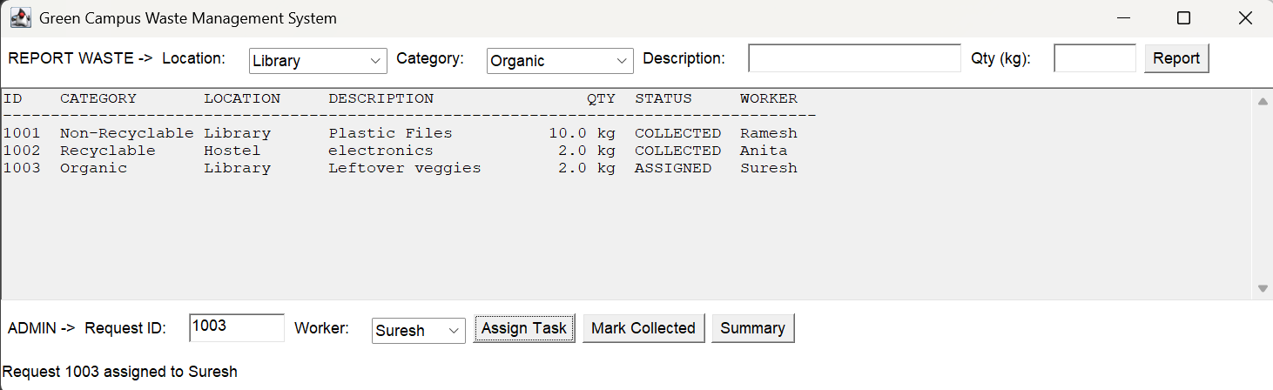
Figure 3: Request 1003 assigned to worker Suresh (status ASSIGNED)
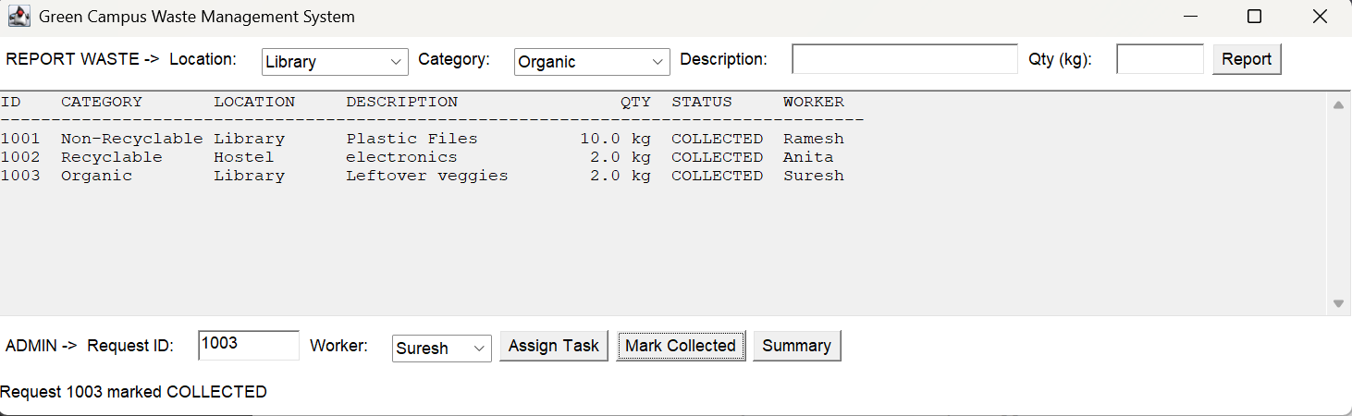
Figure 4: Request 1003 marked COLLECTED

8. Conclusion
The Green Campus Waste Management System provides a simple way to report waste from different campus locations, categorize it, assign collection work to workers and track every request until it is collected. The project successfully applies the major Java concepts: abstraction and inheritance through the Waste class hierarchy, an interface for common actions, polymorphism through category-specific behaviour, collections for data handling, file handling for permanent storage, and the Applet life cycle for the user interface.
Because the design is object-oriented, new waste types (for example e-waste or hazardous waste) can be added by creating one more child class without changing the existing code.
Future Scope
- Login for administrator and workers with separate screens.
- Use of a database such as MySQL instead of a text file.
- Date and time of each request and reports for a selected period.
- Mobile or web version and notifications to workers.

